**Mr. Visca’s: Calculus (sec 6.3)**

**Chpt 6 – Day 3: Integrate by Parts**

Integration by Parts:

There are _________________________ "u" and "dv"

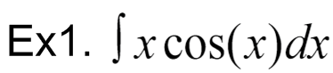

 RICHARD “DICKY” LIPET





This is called “______________________________________________.”

It works when both factors integrate and differentiate _______________.

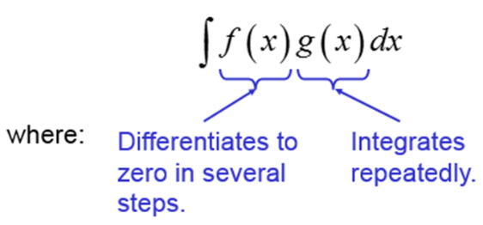

A Shortcut: Tabular Integration - Tabular integration works for integrals of the form:

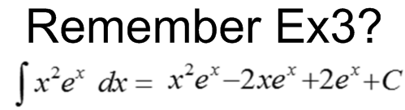

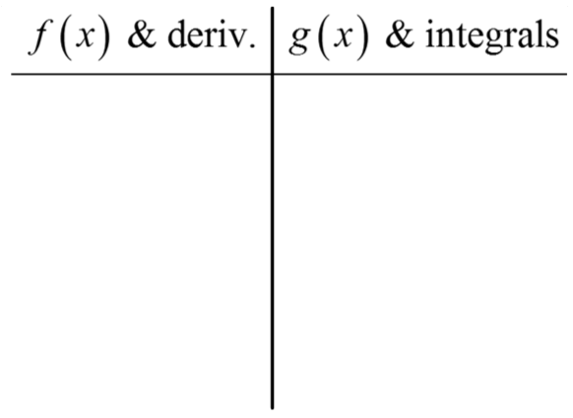

x2 ex

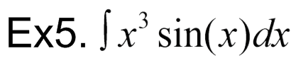



**HW: section 6.3**

#s:1 – 9 odd, 17,18, 21, 22